AIM:
Design Butterworth and Chebyshev filter using bilinear transformation method.
Theory: The bilinear transformation method is commonly used to design analog filters and then convert them into digital filters. This method maps the analog frequency response to the digital frequency response using a bilinear transformation.
The Butterworth and Chebyshev filters are two commonly used filter types. The Butterworth filter has a maximally flat frequency response in the passband, while the Chebyshev filter allows for a sharper transition between the passband and the stopband at the expense of ripples in either the passband or stopband.
Code:
import numpy as np
import matplotlib.pyplot as plt
from scipy.signal import butter, cheby1, lfilter, freqz, bilinear
# ==========================================
# Experiment 4: Filter Design & Filtering
# ==========================================
def design_butterworth_filter(filter_order, cutoff_frequency, sampling_frequency):
analog_b, analog_a = butter(filter_order, cutoff_frequency, analog=True, btype='low')
digital_b, digital_a = bilinear(analog_b, analog_a, sampling_frequency)
return digital_b, digital_a
def design_chebyshev_filter(filter_order, cutoff_frequency, sampling_frequency, ripple):
analog_b, analog_a = cheby1(filter_order, ripple, cutoff_frequency, analog=True, btype='low')
digital_b, digital_a = bilinear(analog_b, analog_a, sampling_frequency)
return digital_b, digital_a
def plot_filter_response(digital_b, digital_a, sampling_frequency):
frequency, magnitude_response = freqz(digital_b, digital_a, fs=sampling_frequency)
plt.figure(figsize=(10, 6))
plt.plot(frequency, np.abs(magnitude_response))
plt.title('Filter Magnitude Response')
plt.xlabel('Frequency (Hz)')
plt.ylabel('Magnitude')
plt.grid(True)
plt.show()
_, impulse_response = freqz(digital_b, digital_a, fs=sampling_frequency, worN=4096)
plt.figure(figsize=(10, 6))
plt.plot(impulse_response)
plt.title('Filter Impulse Response')
plt.xlabel('Samples')
plt.ylabel('Amplitude')
plt.grid(True)
plt.show()
filter_order = 4
cutoff_frequency = 1000
sampling_frequency = 8000
ripple = 0.5
digital_b, digital_a = design_butterworth_filter(filter_order, cutoff_frequency, sampling_frequency)
plot_filter_response(digital_b, digital_a, sampling_frequency)
digital_b, digital_a = design_chebyshev_filter(filter_order, cutoff_frequency, sampling_frequency, ripple)
plot_filter_response(digital_b, digital_a, sampling_frequency)
filter_path = 'filter_coefficients.txt'
np.savetxt(filter_path, np.vstack((digital_b, digital_a)), delimiter=',')
print(f"Filter coefficients saved at: {filter_path}")
# ==========================================
# Additional Task
# ==========================================
fs = 10000
duration = 0.005
t = np.linspace(0, duration, int(fs * duration), endpoint=False)
f1, f2, f3, f4 = 1000, 2000, 3000, 4000
s1 = np.sin(2 * np.pi * f1 * t)
s2 = np.sin(2 * np.pi * f2 * t)
s3 = np.sin(2 * np.pi * f3 * t)
s4 = np.sin(2 * np.pi * f4 * t)
plt.figure(figsize=(10, 8))
plt.subplot(4, 1, 1)
plt.plot(t * 1000, s1)
plt.title('1 kHz Sine Wave')
plt.ylabel('Amplitude')
plt.grid(True)
plt.subplot(4, 1, 2)
plt.plot(t * 1000, s2)
plt.title('2 kHz Sine Wave')
plt.ylabel('Amplitude')
plt.grid(True)
plt.subplot(4, 1, 3)
plt.plot(t * 1000, s3)
plt.title('3 kHz Sine Wave')
plt.ylabel('Amplitude')
plt.grid(True)
plt.subplot(4, 1, 4)
plt.plot(t * 1000, s4)
plt.title('4 kHz Sine Wave')
plt.xlabel('Time (ms)')
plt.ylabel('Amplitude')
plt.grid(True)
plt.tight_layout()
plt.show()
N = 4000
t_fft = np.linspace(0, N / fs, N, endpoint=False)
s_composite = (np.sin(2 * np.pi * f1 * t_fft) +
np.sin(2 * np.pi * f2 * t_fft) +
np.sin(2 * np.pi * f3 * t_fft) +
np.sin(2 * np.pi * f4 * t_fft))
freqs = np.fft.fftfreq(N, 1/fs)[:N//2]
fft_composite = np.abs(np.fft.fft(s_composite)[:N//2]) * (2 / N)
plt.figure(figsize=(10, 5))
plt.subplot(1, 2, 1)
plt.plot(t_fft[:int(fs*0.005)] * 1000, s_composite[:int(fs*0.005)])
plt.title('Composite Signal (Time Domain)')
plt.xlabel('Time (ms)')
plt.ylabel('Amplitude')
plt.grid(True)
plt.subplot(1, 2, 2)
plt.plot(freqs, fft_composite)
plt.title('Composite Signal (Frequency Domain)')
plt.xlabel('Frequency (Hz)')
plt.ylabel('Magnitude')
plt.grid(True)
plt.tight_layout()
plt.show()
digital_b_bw2k, digital_a_bw2k = design_butterworth_filter(filter_order=4, cutoff_frequency=2000, sampling_frequency=fs)
filtered_bw = lfilter(digital_b_bw2k, digital_a_bw2k, s_composite)
fft_bw = np.abs(np.fft.fft(filtered_bw)[:N//2]) * (2 / N)
plt.figure(figsize=(10, 5))
plt.subplot(1, 2, 1)
plt.plot(t_fft[:int(fs*0.005)] * 1000, filtered_bw[:int(fs*0.005)])
plt.title('Butterworth Filter Output (Time Domain)')
plt.xlabel('Time (ms)')
plt.ylabel('Amplitude')
plt.grid(True)
plt.subplot(1, 2, 2)
plt.plot(freqs, fft_bw)
plt.title('Butterworth Filter Output (Frequency Domain)')
plt.xlabel('Frequency (Hz)')
plt.ylabel('Magnitude')
plt.grid(True)
plt.tight_layout()
plt.show()
digital_b_ch3k, digital_a_ch3k = design_chebyshev_filter(filter_order=4, cutoff_frequency=3000, sampling_frequency=fs, ripple=0.5)
filtered_ch = lfilter(digital_b_ch3k, digital_a_ch3k, s_composite)
fft_ch = np.abs(np.fft.fft(filtered_ch)[:N//2]) * (2 / N)
plt.figure(figsize=(10, 5))
plt.subplot(1, 2, 1)
plt.plot(t_fft[:int(fs*0.005)] * 1000, filtered_ch[:int(fs*0.005)])
plt.title('Chebyshev Filter Output (Time Domain)')
plt.xlabel('Time (ms)')
plt.ylabel('Amplitude')
plt.grid(True)
plt.subplot(1, 2, 2)
plt.plot(freqs, fft_ch)
plt.title('Chebyshev Filter Output (Frequency Domain)')
plt.xlabel('Frequency (Hz)')
plt.ylabel('Magnitude')
plt.grid(True)
plt.tight_layout()
plt.show()
Output:
1. Butterworth Filter Responses (fc = 1000 Hz, fs = 8000 Hz)
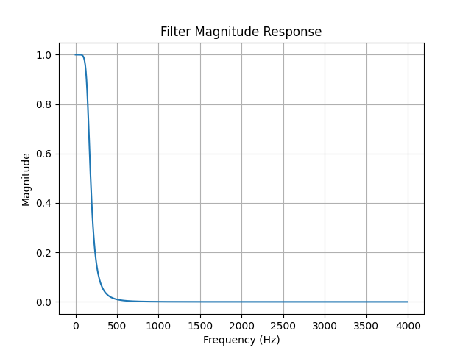
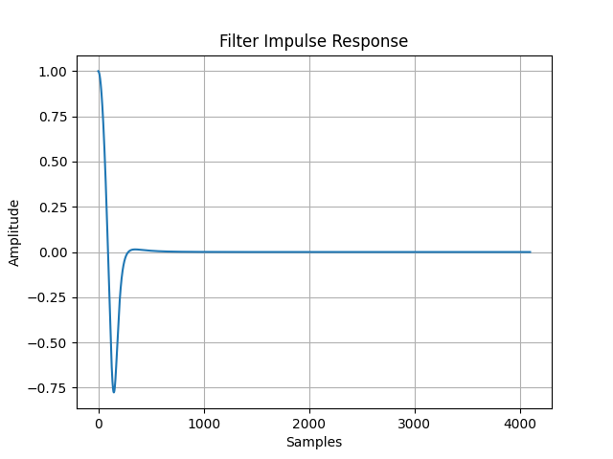

2. Chebyshev Filter Responses (fc = 1000 Hz, fs = 8000 Hz, Ripple = 0.5 dB)
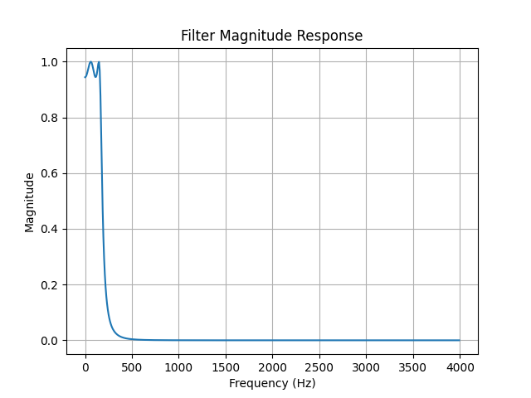
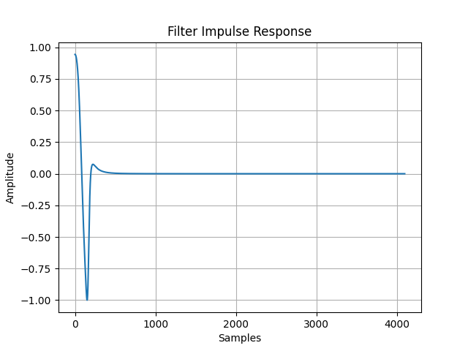

Additional Task Results
1. Individual Discrete Sine Waves (1 kHz, 2 kHz, 3 kHz, 4 kHz)
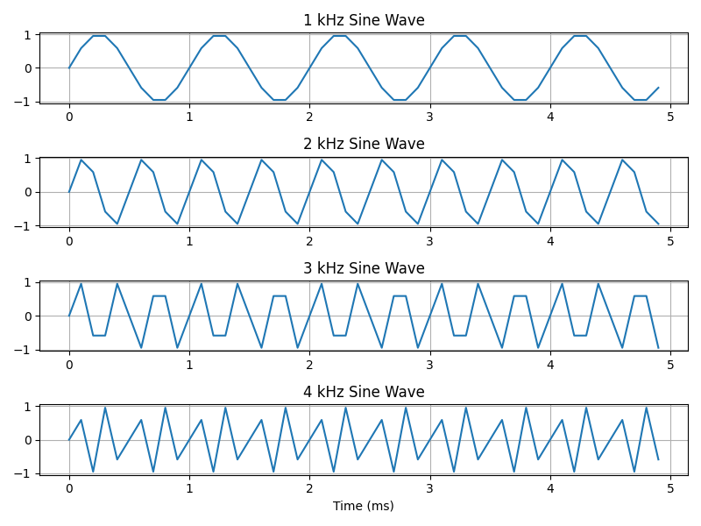

2. Composite Signal (Time & Frequency Domain)
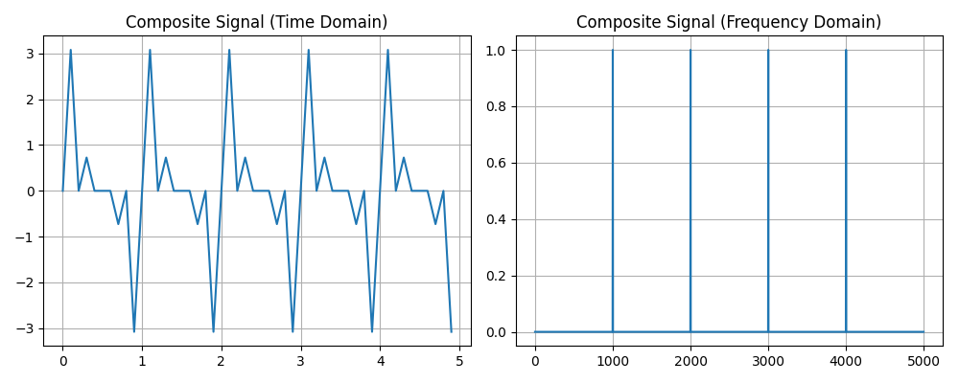
3. Butterworth Digital Filter Output (Cutoff Frequency = 2 kHz)
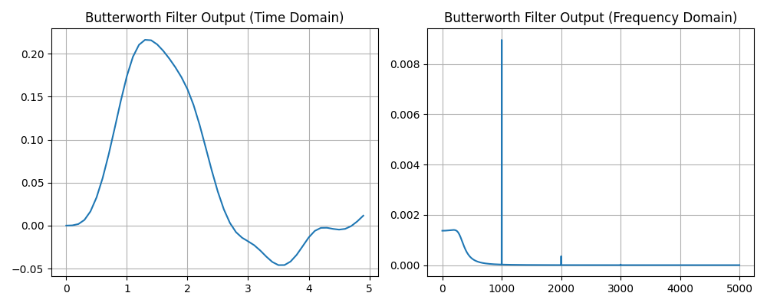

4. Chebyshev Digital Filter Output (Cutoff Frequency = 3 kHz)
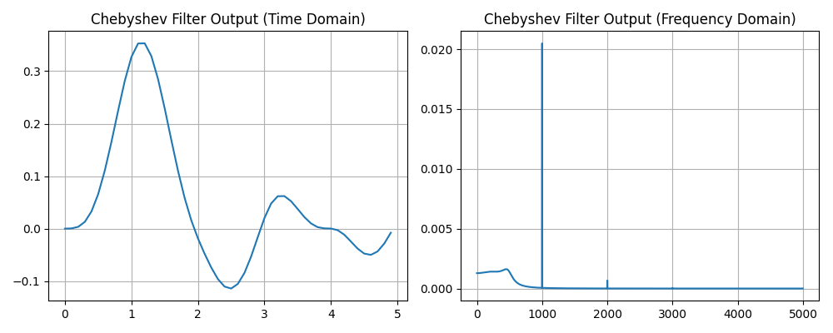
Conclusion:
Digital Butterworth and Chebyshev IIR filters were successfully designed and implemented using the bilinear transformation method. The Butterworth filter exhibits a maximally flat response in the passband without ripples, making it ideal for smooth bandpass signal retention. The Chebyshev Type-1 filter offers a sharper transition between the passband and stopband at the expense of ripples in the passband. The multi-tone sine wave filtration demonstrated that the 2 kHz Butterworth low-pass filter effectively eliminated the 3 kHz and 4 kHz components, while the 3 kHz Chebyshev low-pass filter retained the 1 kHz, 2 kHz, and 3 kHz components while suppressing the 4 kHz tone.

